Information Sharing - Guidance for Derbyshire Early Years and Childcare settings

Information/data sharing is essential for effective safeguarding and promoting the welfare of children and young people. Poor information sharing has, unfortunately, been directly the cause of missed opportunities to take action that keeps children and young people safe.

All practitioners must understand the circumstances in which you can legally retain and share personal information, and that you need to share information to protect vulnerable children. (You may have an information sharing policy which is part of your safeguarding policy, and if so, this should be reviewed regularly with staff).

No practitioner should ever assume that someone else will pass on information about a concern about the safety or wellbeing of a child and they should always follow the setting’s safeguarding policy if they have any concerns.

The seven golden rules to sharing information

- Remember that the General Data Protection Regulation (GDPR), Data Protection Act 2018 and human rights law are not barriers to justified information sharing, but provide a framework to ensure that personal information about living individuals is shared appropriately.
- Be open and honest with the individual (and/or their family where appropriate) from the outset about why, what, how and with whom information will, or could be shared, and seek their agreement, unless it is unsafe or inappropriate to do so.
- Seek advice from other practitioners, or your information governance lead, if you are in any doubt about sharing the information concerned, without disclosing the identity of the individual where possible.
- Where possible, share information with consent, and where possible, respect the wishes of those who do not consent to having their information shared. Under the GDPR and Data Protection Act 2018 you may share information without consent if, in your judgement, there is a lawful basis to do so, such as where safety may be at risk. You will need to base your judgement on the facts of the case. When you are sharing or requesting personal information from someone, be clear of the basis upon which you are doing so. Where you do not have consent, be mindful that an individual might not expect information to be shared.
- Consider safety and well-being: base your information sharing decisions on considerations of the safety and well-being of the individual and others who may be affected by their actions.
- Necessary, proportionate, relevant, adequate, accurate, timely and secure: ensure that the information you share is necessary for the purpose for which you are sharing it, is shared only with those individuals who need to have it, is accurate and up-to-date, is shared in a timely fashion, and is shared securely (see principles).
- Keep a record of your decision and the reasons for it – whether it is to share information or not. If you decide to share, then record what you have shared, with whom and for what purpose.

When and How to share information - See page 4 of this guide for a flowchart

Source “Information Sharing - Advice for practitioners providing safeguarding services to children, young people, parents and carers - July 2018”.
https://assets.publishing.service.gov.uk/government/uploads/system/uploads/attachment_data/file/721581/Information_sharing_advice_practitioners_safeguarding_services.pdf

The General Data Protection Requirements (GDPR) 2018 - The new EU-wide legislation determines how people’s personal data is processed and kept safe, and the legal rights individuals have in relation to their own data. It provides a framework to ensure that personal information about a living individual is shared appropriately and within the law. Most early years settings should be registered with the ICO. www.ico.org.uk

Any concern regarding confidentiality must never be used as a justification for withholding information when it would be in the child’s best interest to share it

The GDPR 2018 includes ‘safeguarding of children and individuals at risk’ as a condition that allows practitioners to share information without consent. Information can also be shared legally without consent, if a practitioner is unable to, cannot be reasonably expected to gain consent from the individual, or if to gain consent could place a child at risk.

A Data Sharing Agreement explains what rules you have set/agreed regarding what and how personal information is shared with other organisations. It usually covers:-

- Why you are sharing the information and who with.
- What you will be sharing, how it will be kept secure.
- How it will be physically shared (such as via secure email or registered post to and named individual at the new settings etc).
- How long the information is stored and where.
- How individuals can access their information and how it will be reviewed

Scenario - If a child is moving on to school or another setting, you may have some information regarding a previous safeguarding concern, which would be knowledge to share with the new school/setting to enable the school/setting to manage this child safely and work with the family. It is vital that this important information is shared in a timely and secure manner and a data sharing agreement between the school/setting may help you effectively manage this.
In line with guidance to Derbyshire schools, we advise the following for Ofsted registered childcare settings regarding the transfer of child protection records:-
It is important to establish an operational protocol around data sharing and the transferring in and out of child protection files, which involves the Designated Safeguarding Lead and demonstrates a safe and consistent practice.

As per the learning from National Serious Case Reviews, children protection files should be forwarded to the receiving school/setting within five working days.
The Child Protection file must be placed in a separate sealed envelope, addressed as Child Protection Record and marked Confidential - FAO Designated Safeguarding Lead. This file should be sent by special delivery or hand delivered to the receiving school/setting. The receiving setting/school should acknowledge the receipt of that file. (Records/details should be kept of this transfer i.e. name signatures dates of person taking responsibility of the records transferred).
You may have your own procedures and forms to manage this, but the recommendation is to check against the set of forms for schools in the documents below to ensure robust practice. This guidance includes templates, guidance about record keeping, what should be contained in a in a child protection file, access to Child Protection Files and Information Sharing etc.
https://schoolsnet.derbyshire.gov.uk/keeping-children-safe-in-education/safeguarding-policies-guidance-and-protocols/child-protection-record-keeping-guidance.aspx

See Derbyshire County Council’s Information Sharing Agreement, between the Local Authority and Derbyshire School’s and academies. https://schoolsnet.derbyshire.gov.uk/performance-information/data-protection-and-foi/information-sharing.aspx

Flowchart of when and how to share information

Source:- Information sharing. Advice for practitioners providing safeguarding services to children, young people, parents and carers DfE July 2018
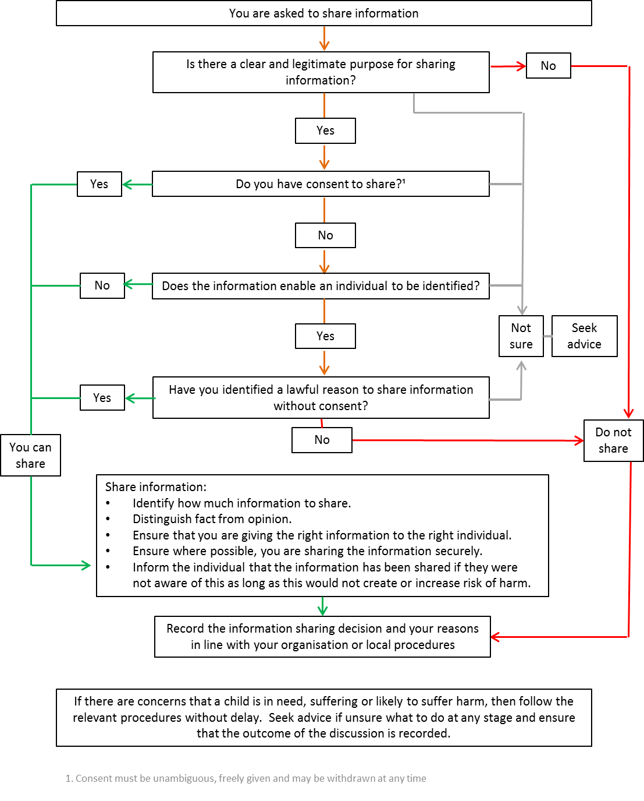

Information sharing guidance

- ICO - data sharing code of practice which gives the ICO’s interpretation of what the law required when sharing personal data https://ico.org.uk/for-organisations/guide-to-data-protection/data-sharing/
- Safeguarding and Information Sharing Advice:- https://www.gov.uk/government/publications/safeguarding-practitioners-information-sharing-advice
- The Foundation Years website has a good practice guide to information sharing in the Foundation Years report (2013). https://www.foundationyears.org.uk/2013/11/information-sharing/
Information regarding GDPR (2018)
- ICO report:- findings from a project designed to help the early years sector improve its data protection compliance https://ico.org.uk/action-weve-taken/audits-advisory-visits-and-overview-reports/nurseries/
- Childcare Organisations and insurance companies such as PACEY, Morton Mitchel, Childcare.co.uk, NDNA, PSLA etc. have all issued guidance on GDPR and provide legal advice. We also have provided guidance on the Derbyshire schools net website. https://schoolsnet.derbyshire.gov.uk/teaching-learning-and-school-governance/early-years-quality-team/news-and-updates.aspx
- ICO (Information Commissioner’s Office) guidance and templates re: meeting the new General Data Protection Requirements (GDPR) and Information Sharing. https://ico.org.uk/for-organisations/resources-and-support.
- Data protection Toolkit - The Department of Education has issued a draft Data Protection a toolkit for schools (Beta version - subject to a review in June 2018). The guidance is to help schools develop policies and processes for data management, from collecting and handling the data through to the ability to respond quickly and appropriately to data breaches.
https://www.gov.uk/government/publications/data-protection-toolkit-for-schools

General Safeguarding information and guidance

- Working Together to Safeguard Children (2018) https://www.gov.uk/government/publications/working-together-to-safeguard-children--2
- Keeping Children Safe in Education (2016) https://www.gov.uk/government/publications/keeping-children-safe-in-education--2
- What to do if you're worried a child is being abused (2015) https://www.gov.uk/government/publications/what-to-do-if-youre-worried-a-child-is-being-abused--2
- Derbyshire Safeguarding Children Board
https://www.derbyshirescb.org.uk/home.aspx
Updated October 2018

